COLLEGE NOTICE CIRCULAR MANAGER
@CREATIVITY THINK (9483175986/7019689991)

ABSTRACT:
College Notice Circular Manager is a dynamic web-based application designed to centralize official notices, circulars, and departmental announcements for educational institutions. The system provides an efficient platform where students can view notices category-wise or department-wise, while staff/admins can upload and manage notices with expiry settings. With a built-in analytics dashboard, admins can track notice views and monitor active and expired circulars. The solution enhances communication efficiency across colleges by ensuring timely and organized dissemination of information..

INTRODUCTION OF THE PROJECT:
Managing and distributing notices in colleges is often inefficient when handled manually or through scattered channels. Students may miss important updates, and retrieving old notices becomes difficult. College Notice Circular Manager solves this issue by creating a centralized web platform where notices are uploaded, categorized, and available to all relevant students instantly. Using Django for the backend and React for the frontend, the system delivers a responsive and user-friendly experience with enhanced accessibility, transparency, and analytics..

PROJECT OBJECTIVES:

• Centralize all college notices and circulars in one web platform
• Provide category-wise and department-wise notice listing
• Enable staff to upload notices with title, file, department, and expiry date
• Allow students to search and download old notices
• Track student views for each notice
• Provide dashboard analytics for active, expired, and most-viewed notices
• Improve communication between administration and students
• Deliver a responsive and easy-to-navigate interface

PROBLEM OF THE STATEMENT:
Colleges often face challenges in distributing notices efficiently, leading to missed information, untracked notices, and communication gaps. Traditional notice boards offer limited accessibility, especially for remote students. Retrieving old circulars is another major problem. College Notice Circular Manager addresses these issues by offering an automated, centralized, searchable, and analytics-driven notice distribution system for students and staff..

MOTIVATION OF THE PROJECT:
• To eliminate manual notice board dependency
• To provide one place for students to check all updates
• To ensure timely communication for all departments
• To allow staff to manage notices digitally with expiry control
• To introduce transparency and tracking through view analytics
• To support digital transformation in educational institutions
• To simplify retrieval of past notices

BLOCK DAIGRAM OF PROJECT:

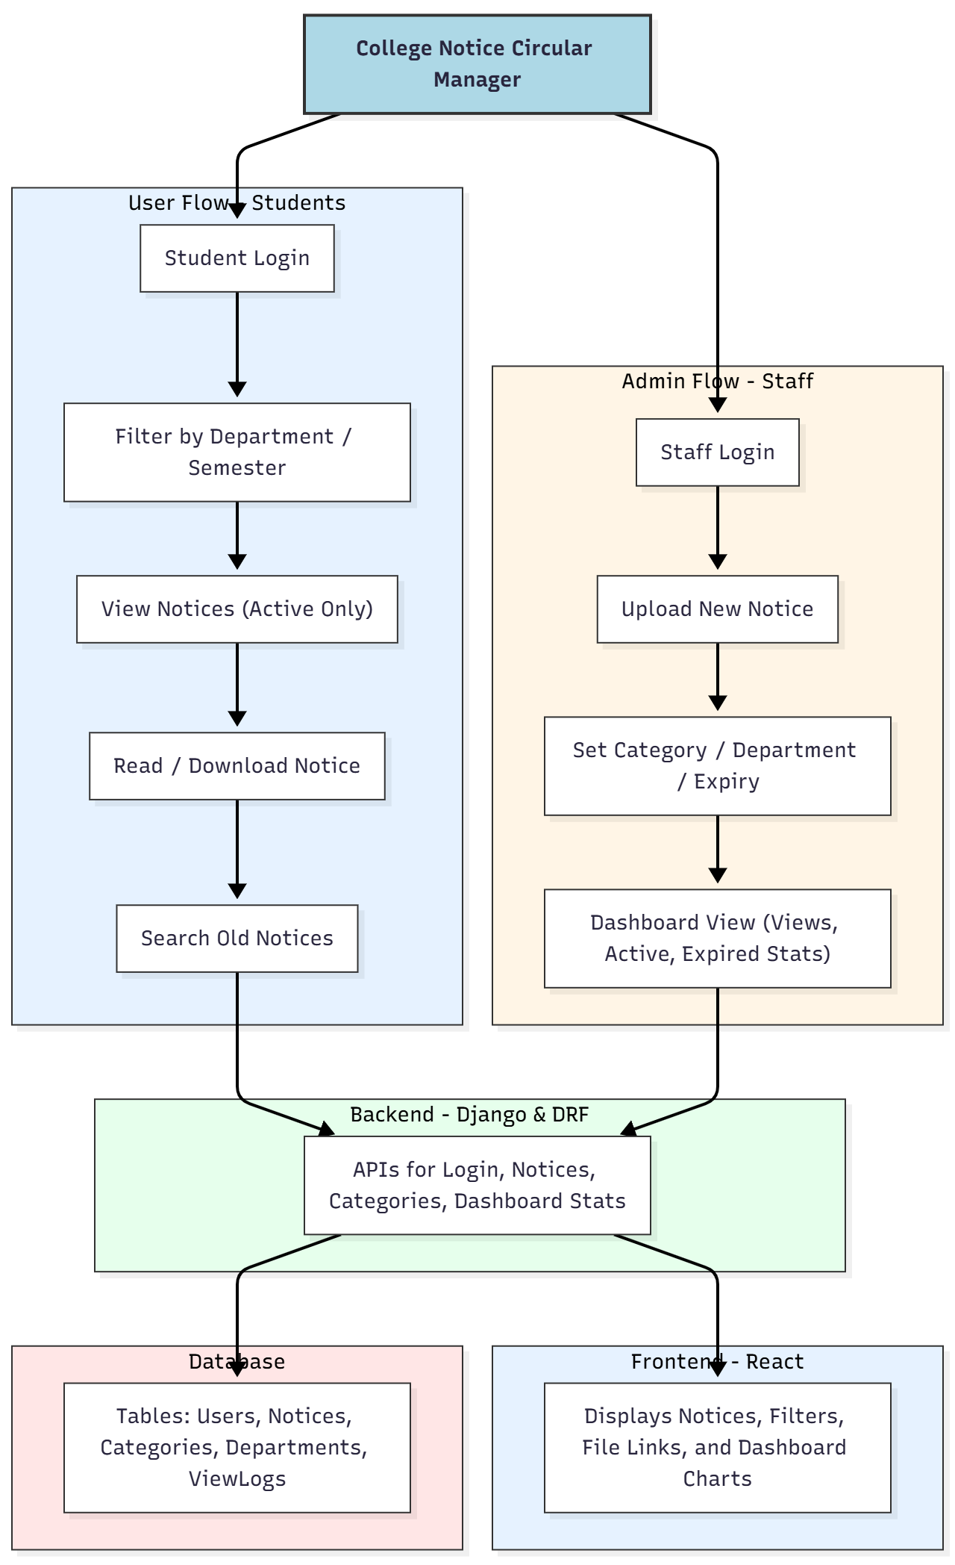

WORKING OF THE PROJECT:
Students and staff access the system through secure login. Students can filter notices based on department or semester, read and download files, and search archived circulars. Each view is stored for analytics. Staff members can upload new notices, select the category and department, and set expiry dates. The dashboard displays view statistics, active/expired notice counts, and departmental distribution. Django APIs handle business logic, while React ensures a smooth and responsive user experience with charts powered by Chart.js..

SOFTWARE REQUIREMENT:
- Backend:
  - Python 3.x
  - Django
  - Django REST Framework
  - SQLite/PostgreSQL
- Frontend:
  - Node.js and npm
  - React.js
  - Axios
- Development Tools:
  - Visual Studio Code
  - Postman (for testing APIs)
  - Git/GitHub (for version control)
- Server/Deployment (Optional):
  - Gunicorn, Nginx, or Heroku/AWS for hosting

ADVANTAGES OF THE PROJECT:

• Centralized notice management system
• Department-wise and category-wise filtering
• Reduces dependency on physical notice boards
• Ensures quick, digital, and accessible communication
• Analytics dashboard improves transparency
• Easy archive search for old circulars
• Secure login for students and staff
• Automated notice expiry system

APPLICATIONS OF THE PROJECT:
• Colleges and universities
• Department-level circular management
• Office administrative notice systems
• Digital bulletin boards

REFERENCES:

- Django REST Framework Documentation — Django Software Foundation. Django Documentation. Available: https://docs.djangoproject.com/
- Django REST Framework. DRF Documentation. Available: https://www.django-rest-framework.org/
- React. React Official Documentation. Available: https://reactjs.org/docs/getting-started.html
- Redux. Redux Documentation. Available: https://redux.js.org/introduction/getting-started
- PostgreSQL Global Development Group. PostgreSQL Documentation. Available: https://www.postgresql.org/docs/
- MySQL. MySQL Reference Manual. Available: https://dev.mysql.com/doc/
- Git. Git Documentation. Available: https://git-scm.com/doc
- Node.js. Node.js Documentation. Available: https://nodejs.org/en/docs/
- Axios. Axios Documentation. Available: https://axios-http.com/docs/intro
- Socket.io Documentation – https://socket.io/docs/

